**SPRINT 1**

|  |  |
| --- | --- |
| TEAM ID | PNT2022TMID51155 |
| PROJECT NAME | Smart Fashion Recommender Application |

CODE AND TEST CASES:

homepage.html <html>

<head>

<title> BEYOND FASHION </title>

</head>

<style>

*{ margin: 0; padding: 0; font-family: "Times New Roman", Times, serif;

} .main{ width: 100%; background-color: #131315; background-position: center; background-size: cover; height: 200%; font-family: "Times New Roman", Times, serif; }

.navbar{ width: 100%; height: 75px; margin: auto; }

.icon{ width: 1000px;

float: left; height: 70px;

}

.logo{ color:#FFFFFF; font-size: 35px;

padding-left: 20px;

float: left; padding-top: 10px;

}

.menu{

width: 400px;

float: left; height: 70px;

}

ul{

float: left; display: flex; justify-content: center; align-items: center;

}

ul li{ list-style: none; margin-left: 62px; margin-top: 27px; font-size: 15px;

}

ul li a{ text-decoration: none; color: #FFFFFF;

font-weight: bold; transition: 0.4s ease-in-out;

}

ul li a:hover{ color: rgb(98, 246, 152);

}

.search{ width: 330px;

float: left; margin-left: 270px;

}

.srch{

width: 200px; height: 40px; background: transparent; border: 1px solid rgb(98, 246, 152); margin-top: 13px; color: #FFFFFF; border-right: none; font-size: 16px; float: left; padding: 10px; border-bottom-left-radius: 5px; border-top-left-radius: 5px;

}

.btn{ width: 100px; height: 40px; background:rgb(98, 246, 152) ; border: 2px solid rgb(98, 246, 152); margin-top: 13px; color: #FFFFFF; font-size: 15px; border-bottom-right-radius: 5px; border-bottom-right-radius: 5px;

}

.btn:focus{ outline: none;

}

.srch:focus{ outline: none;

}

.content{ width: 1200px; height: auto; margin: auto; color: #800080; position: relative;

}

.content.par{ padding-left: 20px; padding-bottom: 25px;

letter-spacing: 1.2px; line-height: 30px;

}

.content h1{

font-size: 50px; padding-left: 20px; margin-top: 9%; letter-spacing: 2px;

}

.content .cn{ width: 160px; height: 40px; background: rgb(98, 246, 152); border: none; margin-bottom: 10px;

margin-left: 20px; font-size: 18px; border-radius: 10px; cursor: pointer; transition: .4s ease;

}

.content .cn a{ text-decoration: none; color: #FBE7A1; transition: .3s ease;

}

.cn:hover{ background-color: #FBE7A1;

}

.content span{ color:rgb(98, 246, 152); font-size: 60px;

}

.form{ width: 250px; height: 380px; background: linear-gradient(to top,hsla(89, 43%, 51%, 0.3)); position: absolute; top: -20px; left: 870px; border-radius: 10px; padding: 25px;

}

.form h2{ width: 220px;

text-align: center; color:rgb(98, 246, 152); font-size: 22px;

border-radius: 10px; margin: 2px; padding: 8px;

}

.form input{ width: 240px; height: 35px; background: rgba(0, 255, 0, 0.5);

}

.form input{

width: 240px; height: 35px; background: rgba(0, 255, 0, 0.5); border-bottom: 1px solid rgb(98, 246, 152); border-top: none; border-right: none; border-left: none; color: #fff; font-size: 15px; letter-spacing: 1px; margin-top: 30px;

}

.form input:focus{ outline: none;

}

::placeholder{ color: #fff;

}

.btnn{ width: 240px; height: 40px; background: rgb(98, 246, 152); border: none; margin-top: 30px; font-size: 18px; border-radius: 10px; cursor: pointer; color: #fff; transition: 0.4s ease;

}

.btnn:hover{ background: #fff; color: rgb(98, 246, 152);

}

.btnn a{ text-decoration: none; color: #000; font-weight: bold;

}

.form .link{

font-size: 17px; padding-top: 20px; text-align: center;

}

.form .link a{ text-decoration: none; color: rgb(98, 246, 152);

}

.liw{ padding-top: 15px; padding-bottom: 10px; text-align: center;

}

img{ width:1300px; color: yellow;

height: 400px; float:left ;

}

</style>

<body>

<div class="main">

<div class="navbar"> <div class="icon">

<h2 class="logo">FASHIONISTA</h2>

</div>

<div class="menu">

<ul>

<li><a href="#">HOME</a></li>

<li><a href="#">ABOUT</a></li>

</ul>

</div>

<div class="search">

<input class="srch" type="search" name="" placeholder="TYPE TO SEARCH">

<a href="#"><button class="btn">SEARCH</button></a>

</div>

<img src="https://smartfashionsfra.s3.jp-tok.cloud-objectstorage.appdomain.cloud/istockphoto-831318986-170667a.jpg">

</div>

</div>

</body>

</html>

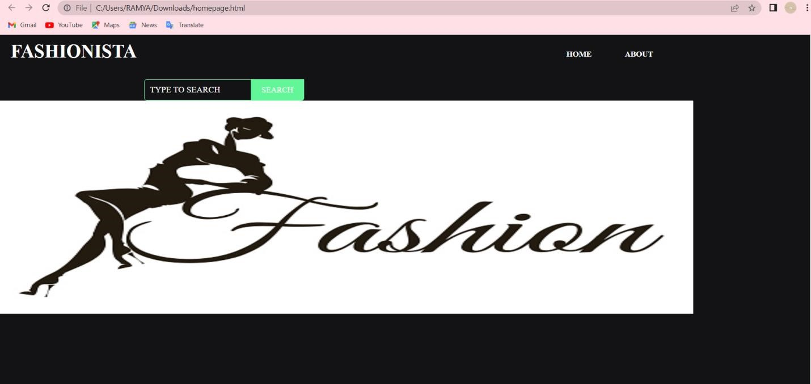

**registerpage.html**

<html>

<head>

<title> BEYOND FASHION </title>

</head>

<style>

*{ margin: 0; padding: 0; font-family: "Times New Roman", Times, serif;

} .main{ width: 100%; background: linear-gradient(to top, rgba(0,0,0,0.5),rgba(0,0,0,0.5)50%); background-position: center;

background-size: cover; height: 100%; font-family: "Times New Roman", Times, serif;

}

.navbar{ width: 100%; height: 75px; margin: auto;

}

.icon{ width: 200px;

float: left; height: 70px;

}

.logo{ color:rgb(98, 246, 152); font-size: 35px;

padding-left: 20px;

float: left; padding-top: 10px;

}

.menu{ width: 400px;

float: left; height: 70px; }

ul{

float: left; display: flex; justify-content: center; align-items: center;

}

ul li{ list-style: none; margin-left: 62px; margin-top: 27px; font-size: 15px; }

ul li a{ text-decoration: none; color: #ffff;

font-weight: bold; transition: 0.4s ease-in-out;

}

ul li a:hover{ color: rgb(98, 246, 152);

}

.search{ width: 330px;

float: left; margin-left: 270px;

}

.srch{

width: 200px; height: 40px; background: transparent; border: 1px solid rgb(98, 246, 152); margin-top: 13px; color: #ffff; border-right: none; font-size: 16px; float: left;

padding: 10px; border-bottom-left-radius: 5px; border-top-left-radius: 5px;

}

.btn{ width: 100px; height: 40px; background:rgb(98, 246, 152) ; border: 2px solid rgb(98, 246, 152); margin-top: 13px; color: #ffff; font-size: 15px; border-bottom-right-radius: 5px; border-bottom-right-radius: 5px;

}

.btn:focus{ outline: none;

}

.srch:focus{ outline: none;

}

.content{ width: 1200px; height: auto; margin: auto; color: #ffff; position: relative;

}

.content.par{ padding-left: 20px; padding-bottom: 25px;

letter-spacing: 1.2px; line-height: 30px;

}

.content h1{

font-size: 50px; padding-left: 20px; margin-top: 9%; letter-spacing: 2px;

}

.content .cn{ width: 160px; height: 40px; background: rgb(98, 246, 152); border: none;

margin-bottom: 10px; margin-left: 20px; font-size: 18px; border-radius: 10px; cursor: pointer; transition: .4s ease;

}

.content .cn a{ text-decoration: none; color: #000; transition: .3s ease;

}

.cn:hover{ background-color: #fff;

}

.content span{ color:rgb(98, 246, 152); font-size: 60px;

}

.form{ width: 250px; height: 380px; background: linear-gradient(to top,rgba(0,0,0,0.8)50%,rgba(0,0,0,0.8)50%); position: absolute; top: -20px; left: 870px; border-radius: 10px; padding: 25px;

}

.form h2{ width: 220px;

text-align: center; color:rgb(98, 246, 152); font-size: 22px;

border-radius: 10px; margin: 2px; padding: 8px;

}

.form input{ width: 240px; height: 35px; background: transparent;

}

.form input{ width: 240px; height: 35px; background: transparent; border-bottom: 1px solid rgb(98, 246, 152); border-top: none; border-right: none; border-left: none; color: #fff; font-size: 15px; letter-spacing: 1px; margin-top: 30px;

}

.form input:focus{ outline: none;

}

::placeholder{ color: #fff;

}

.btnn{ width: 240px; height: 40px; background: rgb(98, 246, 152); border: none; margin-top: 30px; font-size: 18px; border-radius: 10px; cursor: pointer; color: #fff; transition: 0.4s ease;

}

.btnn:hover{ background: #fff; color: rgb(98, 246, 152);

}

.btnn a{ text-decoration: none; color: #000; font-weight: bold;

}

.form .link{

font-size: 17px; padding-top: 20px; text-align: center;

}

.form .link a{ text-decoration: none; color: rgb(98, 246, 152);

}

.liw{ padding-top: 15px; padding-bottom: 10px; text-align: center;

}

</style>

<body>

<div class="main">

<div class="navbar">

<div class="icon">

<h2 class="logo">BEYOND FASHION</h2>

</div>

<div class="menu">

<ul>

<li><a href="#">HOME</a></li>

<li><a href="#">ABOUT</a></li>

</ul>

</div>

<div class="search">

<input class="srch" type="search" name="" placeholder="TYPE TO SEARCH">

<a href="#"><button class="btn">SEARCH</button></a>

</div>

</div>

<div class="content">

<h1>SMART FASHION <br><span>APPLICATION</span></h1>

<div class="form">

<h2>FASHIONISTA REGISTER</h2>

<form action="/Register" method="post">

<input type="text" name="username" placeholder="USERNAME">

<input type="email" name="email" placeholder="EMAIL ID">

<input type="password" name="password" placeholder="PASSWORD"> <button type="SUBMIT" class="btnn">REGISTER</button>

<p class="link">ALREADY HAVE AN ACCOUNT<br>

<a href="/Login">LOG IN</a> here</a></p>

</form>

</div>

</div>

</div>

</body>

</html>

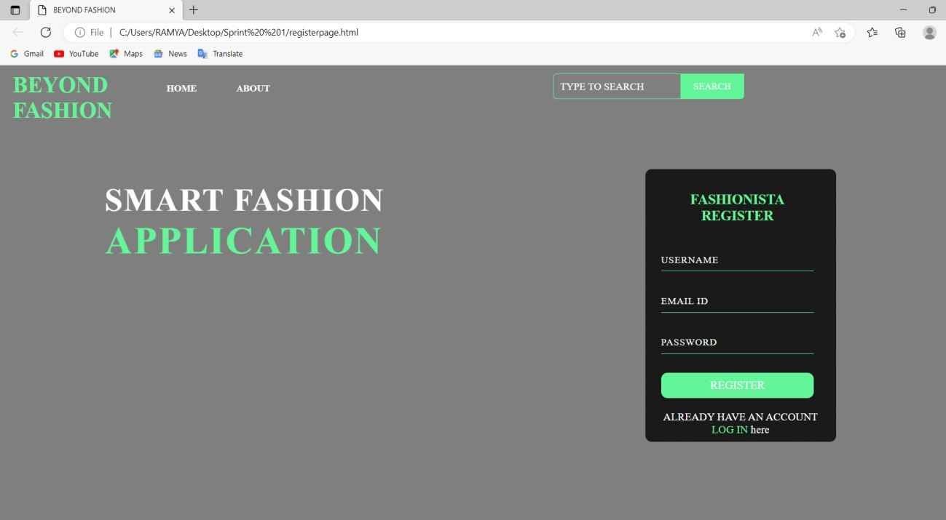

**indexpage.html**

<html>

<head>

<title> BEYOND FASHION </title>

</head>

<style>

*{ margin: 0; padding: 0; font-family: "Times New Roman", Times, serif;

} .main{ width: 100%; background: linear-gradient(to top, rgba(0,0,0,0.5),rgba(0,0,0,0.5)50%); background-position: center; background-size: cover; height: 100%; font-family: "Times New Roman", Times, serif;

}

.navbar{ width: 100%; height: 75px; margin: auto;

}

.icon{ width: 200px; float: left; height: 70px;

}

.logo{ color:rgb(98, 246, 152); font-size: 35px;

padding-left: 20px;

float: left; padding-top: 10px;

}

.menu{ width: 400px;

float: left; height: 70px; }

ul{

float: left; display: flex; justify-content: center; align-items: center;

}

ul li{ list-style: none; margin-left: 62px; margin-top: 27px; font-size: 15px;

}

ul li a{ text-decoration: none; color: #ffff;

font-weight: bold; transition: 0.4s ease-in-out;

}

ul li a:hover{ color: rgb(98, 246, 152);

}

.search{ width: 330px;

float: left; margin-left: 270px;

}

.srch{

width: 200px;

height: 40px; background: transparent; border: 1px solid rgb(98, 246, 152); margin-top: 13px; color: #ffff; border-right: none; font-size: 16px; float: left; padding: 10px; border-bottom-left-radius: 5px; border-top-left-radius: 5px;

}

.btn{ width: 100px; height: 40px; background:rgb(98, 246, 152) ; border: 2px solid rgb(98, 246, 152); margin-top: 13px; color: #ffff; font-size: 15px; border-bottom-right-radius: 5px; border-bottom-right-radius: 5px;

}

.btn:focus{

outline: none;

}

.srch:focus{ outline: none; }

.content{ width: 1200px; height: auto; margin: auto; color: #ffff; position: relative;

}

.content.par{ padding-left: 20px; padding-bottom: 25px;

letter-spacing: 1.2px; line-height: 30px;

}

.content h1{

font-size: 50px; padding-left: 20px; margin-top: 9%; letter-spacing: 2px;

}

.content .cn{ width: 160px; height: 40px; background: rgb(98, 246, 152); border: none; margin-bottom: 10px; margin-left: 20px; font-size: 18px; border-radius: 10px; cursor: pointer; transition: .4s ease;

}

.content .cn a{ text-decoration: none; color: #000; transition: .3s ease;

}

.cn:hover{ background-color: #fff;

}

.content span{ color:rgb(98, 246, 152); font-size: 60px;

}

.form{ width: 250px; height: 380px; background: linear-gradient(to top,rgba(0,0,0,0.8)50%,rgba(0,0,0,0.8)50%); position: absolute; top: -20px; left: 870px; border-radius: 10px; padding: 25px;

}

.form h2{ width: 220px;

text-align: center; color:rgb(98, 246, 152); font-size: 22px;

border-radius: 10px;

margin: 2px; padding: 8px;

}

.form input{ width: 240px; height: 35px; background: transparent;

}

.form input{ width: 240px; height: 35px; background: transparent; border-bottom: 1px solid rgb(98, 246, 152); border-top: none; border-right: none; border-left: none; color: #fff; font-size: 15px; letter-spacing: 1px; margin-top: 30px;

}

.form input:focus{

outline: none;

}

::placeholder{ color: #fff;

}

.btnn{ width: 240px; height: 40px; background: rgb(98, 246, 152); border: none; margin-top: 30px; font-size: 18px; border-radius: 10px; cursor: pointer; color: #fff; transition: 0.4s ease;

}

.btnn:hover{ background: #fff; color: rgb(98, 246, 152);

}

.btnn a{ text-decoration: none; color: #000; font-weight: bold;

}

.form .link{

font-size: 17px; padding-top: 20px; text-align: center;

}

.form .link a{ text-decoration: none; color: rgb(98, 246, 152);

}

.liw{ padding-top: 15px; padding-bottom: 10px; text-align: center; }

</style>

<body>

<div class="main">

<div class="navbar">

<div class="icon">

<h2 class="logo">BEYOND FASHION</h2>

</div>

<div class="menu">

<ul>

<li><a href="#">HOME</a></li>

<li><a href="#">ABOUT</a></li>

</ul>

</div>

<div class="search">

<input class="srch" type="search" name="" placeholder="TYPE TO SEARCH">

<a href="#"><button class="btn">SEARCH</button></a>

</div>

</div>

<div class="content">

<h1>SMART FASHION <br><span>APPLICATION</span></h1>

<div class="form">

<h2>FASHIONISTA REGISTER</h2>

<form action="/Register" method="post">

<input type="text" name="username" placeholder="USERNAME">

<input type="email" name="email" placeholder="EMAIL ID">

<input type="password" name="password" placeholder="PASSWORD">

<button type="SUBMIT" class="btnn">REGISTER</button>

<p class="link">ALREADY HAVE AN ACCOUNT<br>

<a href="/Login">LOG IN</a> here</a></p>

</form>

</div>

</div>

</div>

</body>

</html>

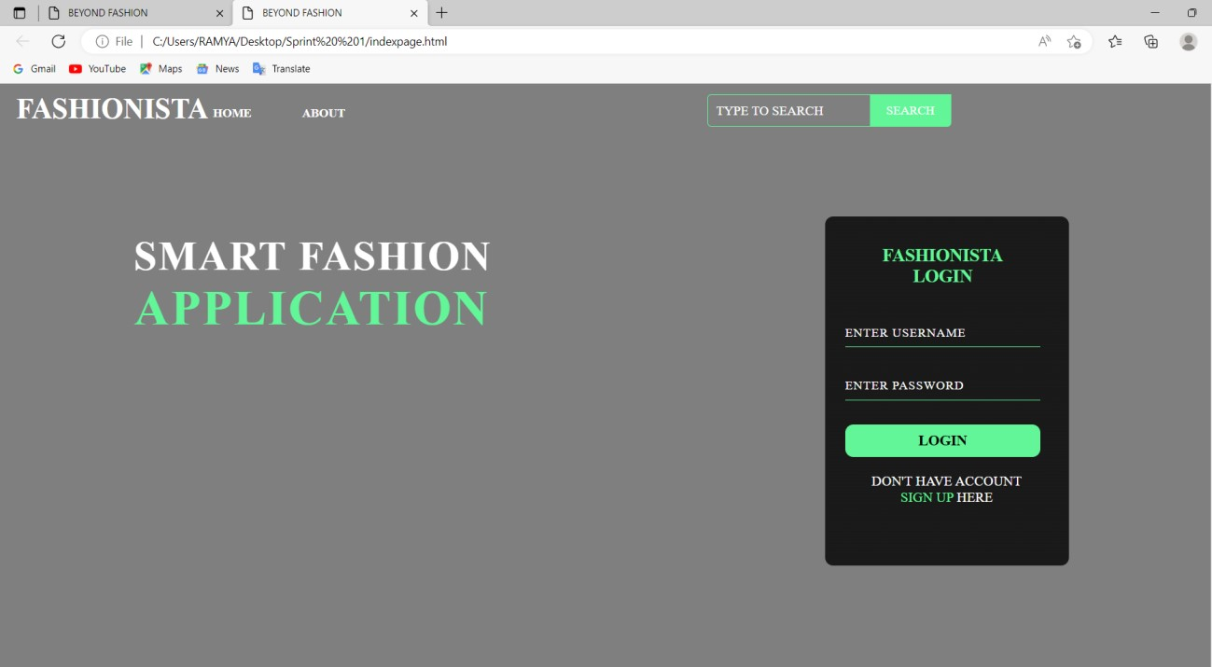

**DATABASE CONNECTION**

